1. Write a program in assembly language to display a two-digit number on the screen. The

two-digits number is required to be taken in the program itself.

Code

ORG 100h

MOV DX, OFFSET msg_output

MOV AH, 09h

INT 21h

MOV AL, '5'

MOV DL, AL

MOV AH, 02h

INT 21h

MOV AL, '6'

MOV DL, AL

MOV AH, 02h

INT 21h

MOV DX, OFFSET msg_end

MOV AH, 09h

INT 21h

MOV AH, 4Ch

INT 21h

msg_output DB 0Dh, 0Ah, 'The required output for the two-digit number is: $'

msg_end DB 0Dh, 0Ah, '$'

END

OutPut:

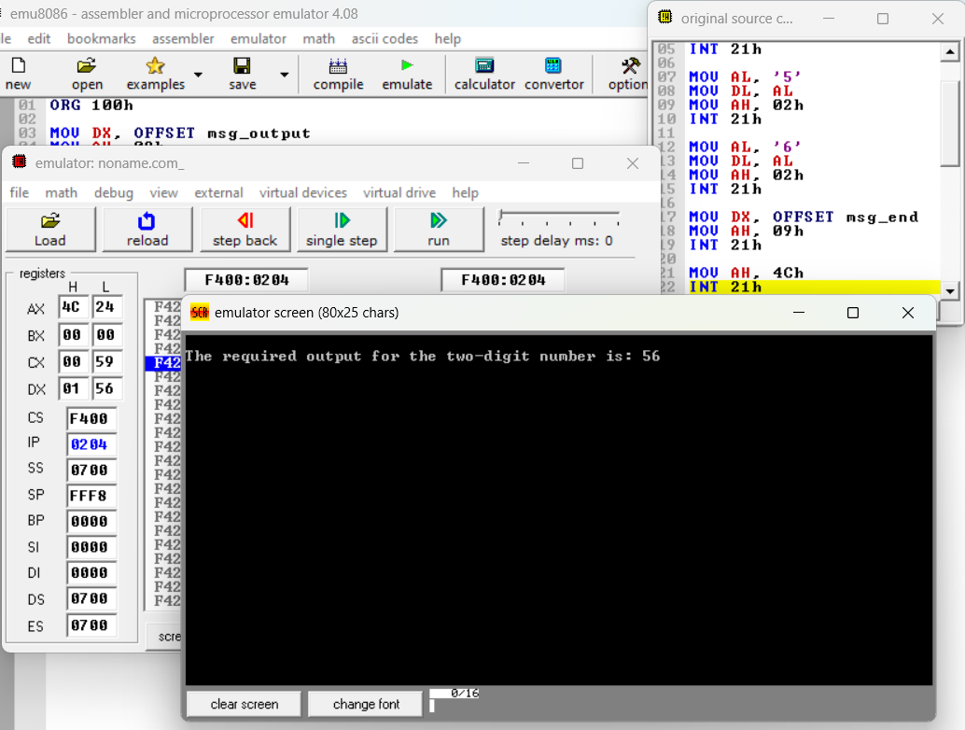

Practice Set:

2. Write an assembly language program to take two single-digit integers from the user and

print the result of addition on the screen.

Code

ORG 100h

mov ah, 09h

lea dx, msg1

int 21h

mov ah, 01h

int 21h

sub al, '0'

mov bl, al

mov ah, 02h

mov dl, 0Dh

int 21h

mov dl, 0Ah

int 21h

mov ah, 09h

lea dx, msg2

int 21h

mov ah, 01h

int 21h

sub al, '0'

add bl, al

mov ah, 02h

mov dl, 0Dh

int 21h

mov dl, 0Ah

int 21h

cmp bl, 9

jg two_digits

mov ah, 09h

lea dx, msg3

int 21h

add bl, '0'

mov dl, bl

mov ah, 02h

int 21h

jmp done

two_digits:

mov ah, 09h

lea dx, msg3

int 21h

mov al, bl

mov ah, 0

mov dl, 10

div dl

add al, '0'

mov dl, al

mov bh, ah

mov ah, 02h

int 21h

mov ah, bh

mov al, ah

add al, '0'

mov dl, al

mov ah, 02h

int 21h

done:

mov ah, 4Ch

int 21h

msg1 db 0Dh, 0Ah, 'Enter first digit: $'

msg2 db 0Dh, 0Ah, 'Enter second digit: $'

msg3 db 0Dh, 0Ah, 'The sum is: $'

OutPut:

